

**1915(c) Home and Community-Based Services Waiver Wait List**

**Management Assessment**

House Bill 6 of the 2024 Legislative Session

**October**

**2024**

|  |  |  |
| --- | --- | --- |
|  |  | **Presented by the Kentucky Department for Medicaid Services** |

**Table of Contents**

**Executive Summary** 3

**Introduction and Background** 5

**Section 1. Wait List Management Data and Policy Assessment** 9

A. Current Eligibility Criteria for the Waiver Program 9

B. Process for an Individual to be Assessed for a Waiver Program 10

C. Level of Priority for Receiving Services for an Individual on the Wait List 14

D. The Number of Current Waiver Participants​ 15

E. Number, Demographics, and Eligibility Category of Individuals on the Wait List​ 16

F. Acuity Level of Individuals on the Wait List​ 19

G. Level of Care and Services Needed by Individuals on the Wait List 26

H. Average Cost of Waiver Services Provided​ 27

I. Date of Entry and Length of Time on the Wait List​ 28

J. Number of Applicants on the Wait List for More Than One Waiver Program 29

**Section 2. Recommendations to Improve HCBS Waiver Wait List Management 30**

**Conclusion 31**

**Appendix A. Acronyms 32**

**Appendix B. 1915(c) HCBS Waiver Enrollment Process Flow 34**

**Appendix C. 1915(c) HCBS Waiver Wait List Management Process Flow (ABI, ABI-LTC, and SCL Waivers) 36**

**Appendix D. 1915(c) HCBS Waiver Wait List Management Process Flow (HCB and MPW Waivers) 37**

**Executive Summary**

The Department for Medicaid Services (DMS) assessed the 1915(c) home-and community-based services (HCBS) waiver wait list population, policies, and management processes in accordance with requirements identified in House Bill 6 (HB 6). The assessment leveraged currently available data using sources such as: waiver policies and administrative regulations, information provided by individuals on the wait lists during the waiver application process, and Medicaid claims data to develop recommendations to improve the wait list management process.

***Key Findings***

* **As of June 30, 2024, 12,847 individuals are on one or more of the HCBS waiver wait lists. Currently four waivers maintain a wait list:** the Acquired Brain Injury-Long Term Care (ABI-LTC), Home and Community Based (HCB), Michelle P. (MPW), and Supports for Community Living (SCL) waivers. The largest wait list is for MPW which includes 9,133 individuals. Close to half (49%) of the individuals on the waiver wait lists are under the age of 18.
  + Many individuals (1,758) are on more than one wait list, resulting in a higher count of total wait list placements of 14,652 due to the duplications.
* **Approximately 88% of the individuals on the wait list have access to Medicaid services through Medicaid Managed Care Organizations (MCOs) or through Fee-for-Service State Plan services**. Of the individuals with access to Medicaid, 30% are currently receiving services though one of the 1915(c) waiver programs. The remaining 11% of individuals on the wait list were identified as not having access to any Medicaid services.
* **MCO risk-stratification data and available Medicaid claims data suggests that the majority of individuals on a wait list are not in high-risk categories or heavy utilizers of Medicaid services. [1], [2]** Most individuals enrolled to MCOs (73%) fall into lower risk stratification categories. Medicaid claims revealed many individuals are not accessing services required by high acuity individuals (i.e., emergency, crisis, and/or inpatient services) and a general low use of non-waiver services (e.g., physical, occupational, and / or speech therapies, home health services).
* **The Cabinet is required to implement new wait list monitoring and management capabilities to meet the requirements outlined in the Centers for Medicare and Medicaid Services’ (CMS) *Ensuring Access to Medicaid Services* Final Rule.[3]** The updated requirements in the Final Rule will mandate regular public reporting on the wait list population and overall management processes. The deadline for implementing the federal requirements is July 2027. The recommendations outlined in this report will move Kentucky toward full compliance with CMS requirements.

***Recommendations***

Based on findings from the assessment, the Cabinet developed three actionable recommendations to better manage wait list operations going forward and to align with the requirements of CMS’ Final Rule. **Table 1** below outlines the recommendations and provides the Cabinet’s tentative implementation timeline.

**Table 1. Wait List Management Recommendations and Implementation Timeline**

| **Recommendation** | **Implementation Timeline** |
| --- | --- |
| 1. **Align Wait List Administrative Regulations and Policies Across Waivers:** The Cabinet will implement policy changes to confirm wait list management processes and requirements are aligned across all HCBS waiver programs and streamlined for waivers that share target populations. | Oct. 2024 – Mar. 2027  (29 months) |
| 1. **Standardize Waiver Application and Eligibility Review Process:** The Cabinet will enhance wait list information gathering processes to confirm waiver eligibility prior to placing individuals on the wait lists and allow for urgency of need review to prioritize slot allocation to individuals with the highest level of need. | Oct. 2024 – Aug. 2026  (23 months) |
| 1. **Modernize Wait List Management Data Collection Systems:** The Cabinet will integrate data collection and analysis into available tools to develop a publicly available wait list data dashboard. The dashboard will help the Cabinet deliver data driven updates to CMS, the Kentucky General Assembly, individuals on the wait lists, and other public stakeholders (e.g., advocacy groups). A dashboard will also help the State meet Federal Requirements per the Ensuring Access to Medicaid Services Final Rule. | Oct. 2024 – Aug. 2026  (23 months) |

**Introduction and Background**

***Background***

In April 2024, the Kentucky General Assembly requested that the Department for Medicaid Services (DMS) to “conduct an analysis and assessment of the wait lists for all the Kentucky 1915(c) home and community-based services (HCBS) waiver programs”.[4] The following report components were indicated in the bill:

1. The current eligibility criteria for the waiver program
2. A description of the process for an individual to be assessed for a waiver program
3. A description of the method used to determine the level of priority for receiving services for an individual on the wait list
4. The number of current waiver participants
5. The number, demographics, and eligibility category of individuals on the wait list
6. The acuity level of individuals on the wait list
7. The level of care and services needed by individuals on the wait list
8. The average cost of waiver services provided
9. The date of entry and length of time on the wait list
10. The number of applicants on the wait list for more than one waiver program as can most accurately be determined

The bill also required DMS to provide recommendations to increase efficiency of the wait list management process. The resulting report is due to the Interim Joint Committees on Appropriations and Revenue and Health Services by October 1, 2024.

DMS collaborated with the Department for Aging and Independent Living (DAIL) and the Department for Behavioral Health, Developmental, and Intellectual Disabilities (DBHDID) to perform an assessment that fulfills the bill’s requirements. Information in the assessment reflects wait list counts and wait list management processes and policies as of June 30, 2024 (i.e., the end of State Fiscal Year (SFY) 2024).

***Kentucky’s Medicaid 1915(c) Home- and Community-Based Services Waiver Programs and Wait Lists***

Kentucky offers six Medicaid 1915(c) HCBS waivers for individuals who meet defined eligibility criteria for institutional setting level of care standards and prefer to receive services at home or in the community. [5],[6] Each HCBS waiver includes a specified enrollment cap, which is agreed to by the Centers for Medicare and Medicaid Services (CMS) during the waiver approval process.[7] When waiver enrollment meets the waiver cap, states are required to maintain waiver wait lists for individuals interested in the applicable waiver program. As of June 30, 2024, four of the HCBS waivers had wait lists. **Table 2** below provides an overview of the six waiver programs in Kentucky and demonstrates whether the waiver has a current wait list.

**Table 2: HCBS Waivers and Waiver Wait List Status [8]**

| **HCBS Waiver** | **Wait List Status as of**  **June 30, 2024 (Yes / No)** |
| --- | --- |
| **Acquired Brain Injury Waiver (ABI)****[9]**  Assists individuals with acquired brain injuries to function independently within their communities by providing intensive rehabilitation services that enable participants to remain in or return to the community in the least restrictive setting possible. | **No**  Funded Enrollment Cap: 383  # Enrolled: 204  # Available Slots: 124  # Reserved Slots: 4  # Applications In Process: 51  **# Wait List: 0**  # On Other Waivers: N/A  # On Other Wait List(s): N/A |
| **Acquired Brain Injury – Long-Term Care (ABI-LTC)9**  Provides services and supports to individuals with an acquired brain injury who have reached a plateau in their rehabilitation and still require maintenance services to live safely in the community. This program is a companion to Kentucky’s ABI waiver, which is focused on intensive rehabilitation. | **Yes**  Funded Enrollment Cap: 438  # Enrolled: 353  # Available Slots: 21  # Reserved Slots: 0  # Applications In Process: 64  **# Wait List: 3 [10]**  # On Other Waivers: 1  # On Other Wait List(s): 0 |
| **Home and Community Based (HCB)[11]**  Provides services to help elderly participants and adults and children with physical disabilities stay in their homes and remain an integral part of their communities. | **Yes**  Funded Enrollment Cap: 17,050  # Enrolled: 13,289  # Available Slots: 1,721  # Reserved Slots: 0  # Applications In Process: 2,040  **# Wait List: 1,987**  # On Other Waivers: 2  # On Other Wait List(s): 287 |
| **Michelle P. Waiver (MPW)[12]**  Provides personalized community-based services in the individual’s own home or family home to prevent individuals with intellectual or developmental disabilities from being admitted to a nursing facility or an Intermediate Care Facilities for Individuals with Intellectual Disabilities (ICF/IID) and supports those who are transitioning from institutional services back into the community. | **Yes**  Funded Enrollment Cap: 10,600  # Enrolled: 9,160  # Available Slots: 654  # Reserved Slots: 0  # Applications In Process: 786  **# Wait List: 9,133**  # On Other Waivers: 2,372  # On Other Wait List(s): 1,754 |
| **Model II Waiver (MIIW)[13]**  Offers services to participants who use a ventilator for 12 or more hours a day and/or are in an active weaning program to prevent institutionalization. | **No**  Funded Enrollment Cap: 100  # Enrolled: 8  # Available Slots: 76  # Reserved Slots: 8  # Applications In Process: 8  **# Wait List: 0**  # On Other Waivers: N/A  # On Other Wait List(s): N/A |
| **Supports for Community Living Waiver (SCL)[14]**  Provides comprehensive community-based services to prevent individuals with intellectual or developmental disabilities from being admitted to an Intermediate Care Facility for Individuals with Intellectual Disabilities (ICF/IID) and supports those who are transitioning from institutional services back into the community. | **Yes**  Funded Enrollment Cap: 5,041  # Enrolled: 4,215  # Available Slots: 245  # Reserved Slots: 23  # Applications In Process: 558  **# Wait List: 3,529**  # On Other Waivers: 2,027  # On Other Wait List(s): 1,522 |

***Additional Items Impacting the Number of Individuals on the Wait List and Wait List Management Processes***

During the wait list assessment process, two additional factors emerged that will impact the Cabinet’s future-state approach to 1915(c) waiver wait list management:

* **Centers for Medicare and Medicaid Services’ (CMS) *Ensuring Access to Medicaid Services* Final Rule**: In May 2024, CMS released *Ensuring Access to Medicaid* Final Rule which includes updated requirements regarding wait list management and public reporting.[15] The rule mandates the reporting of 1915(c) waiver program wait lists and wait list management processes to CMS and to external stakeholders. The implementation deadline for the federal rule is July 2027.

Current data reporting capabilities would benefit from enhancement in order to fully meet the expectations set forth by CMS regarding reporting and management of HCBS wait lists in the Access rule.

* **Additional Funding for HCBS Waiver Slots in SFYs 2025 and 2026:** If needed, during each budget review cycle, the Cabinet requests funding from the General Assembly for additional waiver slots. Within HB 6, the General Assembly decided to fund an additional 1,925 of the requested waiver slots beginning in SFY 2025.[16] **Table 3** below illustrates which waivers received additional funding and the allocated slots by State Fiscal Year. The newly available funding will support the Cabinet to provide services to individuals on the waiver wait lists (i.e., 100% of individuals on the ABI-LTC wait list, 38% of individuals on the HCB wait list, 8% of individuals on MPW wait list, and 11% of individuals on the SCL wait list).[17]

**Table 3: Impact of Additional HCBS Waiver Slots on Wait List Volume**

| **State Fiscal Year (SFY)** | **HCBS Waiver** | | | | **Total** |
| --- | --- | --- | --- | --- | --- |
| **ABI-LTC** | **HCB** | **MPW** | **SCL** |
| **SFY 2025:**  *July 1, 2024 – June 30, 2025* | 25 slots | 250 slots | 250 slots | 125 slots | **650 slots** |
| **SFY 2026:**  *July 1, 2025 – June 30, 2026* | 25 slots | 500 slots | 500 slots | 250 slots | **1,275 slots** |
| **Total** | 50 slots | 750 slots | 750 slots | 375 slots | **1,925 slots** |

**Section 1. Wait List Management Data and Policy Assessment**

In response to HB 6, the Cabinet has conducted an assessment of the current HCBS wait lists, wait list management processes, and Cabinet policies that impact the wait list. The assessment was developed to include the items listed on page 5.

The sections below provide an overview and summary of the items requested by the General Assembly in HB 6. The sections also include additional background information and areas of consideration to help bolster understanding of the summaries.

**A. Current Eligibility Criteria for the Waiver Program**

A person may be eligible for a HCBS waiver program if the applicant meets the following eligibility criteria:[18]

* Meets the technical and financial qualifications for Medicaid. Waiver participants must also meet resource limit requirements to receive waiver services.
* Have documentation to validate the diagnosis of a medical condition or developmental disability.
* Choose to live at home and seek HCBS waiver services.
* Meet the waiver-specific institutional level of care criteria considering medical diagnosis, age-related dependencies, care needs, services, personnel required to meet those needs, and the feasibility of meeting those needs through alternative or non-institutional services.

In addition to the eligibility criteria that apply to all six of the waiver programs, the individual programs also have waiver-specific eligibility criteria outlined in their program-specific Kentucky Administrative Requirements (KARs) and the 1915(c) waiver application. **Table 4** outlines the age and diagnostic criteria and additional level of care requirements used for each HCBS waiver program.

**Table 4: HCBS Waiver-Specific Eligibility Criteria**

| **Waiver** | **Age and Diagnostic Criteria** | **Additional Requirements** |
| --- | --- | --- |
| **Acquired Brain Injury (ABI)**  907 KAR 3:090 | Age 18 or older with acquired brain injury (structural, non-degenerative) | * Meet the requirements for residence in a nursing facility * Exhibit cognitive, behavioral, motor, or sensory damage with an indication for rehabilitation and retraining potential |
| **Acquired Brain Injury Long Term Care (ABI-LTC)**  907 KAR 3:210 | Age 18 or older with acquired brain injury (structural, non-degenerative) | * Meet the requirements for residence in a nursing facility * Have an ABI which necessitates supervision, rehabilitative services, and long term supports |
| **Home and Community Based Waiver (HCB)**  907 KAR 7:010 | Age 65 or older or physical disability | * Would be admitted to a nursing facility without waiver services |
| **Michelle P. Waiver (MPW)**  907 KAR 1:835 | Intellectual and / or Developmental Disability (I/DD) as it is defined in section 1 of the KAR | * Would be admitted to an intermediate care facility for individuals with an intellectual disability (ICF/IID) or a nursing facility if not for waiver services * Require a protected environment while learning living skills, gaining educational experiences, and developing an awareness of the environment |
| **Model II Waiver (MIIW)**  907 KAR 1:595 | Dependence on a ventilator for 12 or more hours a day | * Have a permanent tracheostomy for positive pressure ventilation * Is in an active weaning program * Require 24-hour a day, high-intensity nursing care services * Have a strong family support system, including a primary and secondary caregiver * Have a primary caregiver who understands the purposes, responsibilities, risks and benefits of home ventilator therapy |
| **Supports for Community Living (SCL)**  907 KAR 12:010 | Intellectual and / or Developmental Disability (I/DD) | * Meet the requirements for residence in an intermediate care facility for individuals with an intellectual disability (ICF/IID) |

**B. Process for an Individual to be Assessed for a Waiver Program**

Based on Kentucky Administrative Regulation requirements and internal Cabinet policies and procedures, the Cabinet engages in a multi-step process to assess applicant eligibility for HCBS waiver programs.

Steps in the process include:

1. Obtaining a participant’s waiver application and confirming the applicant is either currently enrolled in or allows the individual to apply for Medicaid services.
2. The Cabinet then reviews the waiver application along with waiver-specific supporting documents, to determine if a potential waiver participant meets waiver targeting criteria.
3. Finally, the applicant’s level of care and service needs are assessed using program-specific functional assessment tools.
   1. *Note: The Cabinet only performs a level of care assessment once a potential waiver participant meets waiver-specific targeting criteria AND a slot on the desired waiver program becomes available.*
4. Applicants are also assessed on whether they meet financial eligibility criteria for Medicaid and HCBS waivers. Financial eligibility review and determination is performed by the Kentucky Department for Community Based Services (DCBS).

Kentucky’s HCBS waivers have a limited number of approved and funded waiver slots available for prospective participants each year. When a slot is not actively available, individuals interested in enrolling in a waiver are placed on waiver-specific wait lists. Individuals are placed on the wait list after submitting their initial waiver application and either confirming Medicaid enrollment or submitting a Medicaid application. Prior to being added to the wait list, individuals are reviewed for potential prioritization as described in **Section C** on page 12.

The summary below offers a step-by-step overview of the waiver application and assessment process. A full process flow of the waiver enrollment process can be found in **Appendix B: 1915(c) HCBS Waiver Enrollment Process Flow.**

***Initial Waiver Application***

To begin the process, an application initiator submits a *Kentucky Medicaid Waiver Application* on behalf of a potential waiver participant via the Medicaid Waiver Management Application (MWMA), the current system of record for 1915(c) waiver operations.[19] An individual or their authorized representative can also submit the waiver application via Kynect, Kentucky’s online state benefits portal.

Potential HCBS waiver participants can only be considered for waiver programs if:

* The individual is already enrolled in Medicaid, or
* An application initiator submitted a Medicaid application to the DCBS on their behalf.

Prior to submitting the application, potential enrollees are required to confirm current enrollment in Medicaid or to submit a Medicaid application to confirm financial eligibility for a waiver. DCBS is responsible for determining Medicaid and financial eligibility for potential HCBS waiver participants.[20]

In addition, potential participants are also required to submit waiver-specific documentation as part of the application process. **Table 5** below outlines the documentation required to apply to each waiver.

**Table 5: Required Documentation to Apply to Each HCBS Waiver**

| **Waiver** | **Required Documentation** |
| --- | --- |
| **Acquired Brain Injury (ABI)** | * Kentucky Medicaid Waiver Intake Application * Map 10: Waiver Services – Physician’s Recommendation[21] * Proof of Brain Injury (i.e., CT scan, MRI, or Discharge Summary) |
| **Acquired Brain Injury Long Term Care (ABI-LTC)** | * Kentucky Medicaid Waiver Intake Application * Map 10: Waiver Services – Physician’s Recommendation * Proof of Brain Injury (i.e., CT scan, MRI, or Discharge Summary) |
| **Home and Community Based Waiver (HCB)** | * Kentucky Medicaid Waiver Intake Application * Map 10: Waiver Services – Physician’s Recommendation |
| **Michelle P. Waiver (MPW)** | * Kentucky Medicaid Waiver Intake Application * MAP-115-Participant Authorization Form (when applicable) |
| **Model II Waiver (MIIW)** | * Kentucky Medicaid Waiver Intake Application * Map 10: Waiver Services – Physician’s Recommendation |
| **Supports for Community Living (SCL)** | * Kentucky Medicaid Waiver Intake Application * Psychological Exam with full-scale Intelligence Quotient (IQ) test * Adaptive Behavior Assessment |

***Targeting Criteria Evaluation***

DMS uses the waiver applications as a first line of evaluation for prospective participants and to route to the appropriate waiver for review. Each application is screened for completion. Once the required documentation is verified to be present, the waiver’s designated Operating Agency determines whether an individual meets targeting criteria for HCBS waiver services. If the individual meets targeting criteria, DMS or the waiver Operating Agency identifies whether a slot is available on the desired waiver program. If a slot is available on the desired waiver program, the individual will require a functional assessment to gather more detailed information about the prospective participant’s needs that inform a person-centered service plan. The section below offers additional information about the clinical eligibility review process.

If a slot is not available on the desired waiver program, the individual is placed on the wait list for the respective waiver program for which it was determined targeting criteria was met. The Cabinet also attempts to place individuals on an alternative HCBS waiver if the individual’s eligibility aligns with the waiver program’s target population and the individual’s specific needs.

Annually, the Cabinet confirms ongoing interest in waiver services by sending letters to individuals on the wait lists. The letter informs individuals to notify the Cabinet if they no longer want to be on the wait list. The letter also informs them how to get information updated if it is no longer accurate.

***Level of Care and Financial Eligibility Review Process***

If the Cabinet determines an individual meets all initial eligibility and enrollment requirements for a waiver and a waiver slot is available, the individual undergoes a functional assessment. Findings from the functional assessment are used to verify level of care and to determine the extent of the individual’s needs. **A waiver slot must be available for an individual to undergo a functional assessment. The Cabinet does not complete a functional assessment for an individual on a wait list awaiting a slot.**

As part of the level of care review process, assessors conduct an independent functional assessment for each potential enrollee. The Cabinet uses the results of the functional assessment and waiver-specific criteria - such as age, diagnosis, functional needs, and a physician-verified recommendation - to determine eligibility and whether an applicant meets level of care criteria. The criteria help to identify who may qualify for respective waiver programs and who does not meet the necessary requirements. During this process, the assessor may capture findings that differ from the initial application and may demonstrate that a person does not present with observed need for HCBS. If that is the case, an applicant may be denied eligibility for the waiver program due to not meeting level of care requirements. The individual has appeal rights if a denial is determined.

Functional assessment tools used to assess whether an individual meets level of care requirements for a waiver vary by program. **Table 6** below outlines which tool is used for each program, who is conducting the assessment, and when during the enrollment process the assessment is conducted.

**Table 6: Functional Assessment Tools Used to Determine Waiver Eligibility**

| **Waiver** | **Functional Assessment Tool** | **Assessor[22]** | **Timing of Assessment** |
| --- | --- | --- | --- |
| **Acquired Brain Injury (ABI)** | MAP 351 (Medicaid Waiver Assessment) | ABI traditional Case Manager or a Support Broker from a Community Mental Health Center or their local Area Development District | Prior to enrollment |
| **Acquired Brain Injury Long Term Care (ABI-LTC)** | MAP 351 (Medicaid Waiver Assessment) | ABI traditional Case Manager or a Support Broker from a Community Mental Health Center or their local Area Development District | Prior to enrollment |
| **Home and Community Based Waiver (HCB)** | Kentucky Home Assessment Tool (KHAT) | University of Kentucky Nurse Assessor (Contracted by DMS) | Prior to enrollment |
| **Michelle P. Waiver (MPW)** | MAP 351 (Medicaid Waiver Assessment) | Community Mental Health Center Employee | Prior to enrollment |
| **Model II Waiver (MIIW)** | MAP 351-A (Medicaid Waiver Assessment) | Case Management Agency and Case Manager / Assessor | Prior to enrollment |
| **Supports for Community Living (SCL)** | Adaptive Behavior Assessment (initial level of care only prior to enrollment)  Supports Intensity Scale (SIS) | Licensed Psychologist  SIS Assessor | Less than two years old  After enrollment, Case Manager to schedule SIS[23] |

After level of care has been determined, DCBS initiates a financial eligibility review. The objective of this review is to determine current Medicaid enrollment status and/or any waiver-specific financial requirements to receive Medicaid services. DCBS confirms Medicaid / financial eligibility after DMS has reviewed an individual’s level of care documentation (i.e., waiver-specific application materials and functional assessment results). An individual can be placed on a wait list before financial eligibility has been confirmed. DCBS notifies DMS and its designated operating agency partner that a potential waiver participant is eligible for waiver services through MWMA following their level of care assessment.

If an individual meets all waiver criteria (i.e., functional requirements and Medicaid / financial requirements), the individual is approved to begin using waiver services and the applicant is enrolled in the waiver. The Cabinet will send a letter to the new enrollee informing them they have been added to the waiver and prompting them to select a case manager or case management agency. The enrollee will then work with the selected case manager to develop their respective plan of care (i.e., their Person-Centered Service Plan (PCSP)).

**C. Level of Priority for Receiving Services for an Individual on the Wait List**

When placing individuals on a waiver-specific wait list, the ABI, ABI-LTC, and SCL wait lists organize potential participants on their wait lists first by “prioritization of need” categories. These categories indicate the urgency with which an individual needs to access waiver services. Individuals with a higher urgency of need for waiver services are placed higher on the wait list than those with less urgent level of need. The category of need differs between ABI / ABI-LTC and SCL. **Table 7** includes the waiver-specific categories of need and the Cabinet’s approach to determine those levels.

**Table 7: Prioritization of Need Categories and Applicant Review Process**

|  |  |
| --- | --- |
| **Acquired Brain Injury (ABI)** and **Acquired Brain Injury – Long Term Care (ABI-LTC) Waivers** | |
| **Categories of Need:** | * ***Emergency:*** Applicant is currently demonstrating behavior related to their brain injury that places the individual, caregiver, or others at risk of significant harm or has resulted in the applicant being arrested.[24] * ***Non-emergency:*** All other individuals on the wait list. |
| **Review Process:** | To be placed in the emergency category, a review committee composed of three individuals with professional or personal experience with brain injury and cognitive disabilities will consider whether a potential enrollee meets “emergency” category criteria.[25] |
| **Supports for Community Living (SCL) Waiver** | |
| **Categories of Need:** | * ***Emergency:*** Immediate need for waiver services if all other service options have been explored and exhausted. “Emergency” situations include:   + Abuse, neglect, or exploitation of the individual as substantiated by DCBS.   + The death of the individual’s primary caregiver and lack of an alternative primary caregiver.   + The lack of appropriate placement for the individual due to     - Loss of housing     - Loss of funding; or     - Imminent discharge from a temporary placement.   + Jeopardy to the health and safety of the individual due to primary caregiver’s physical or mental health status.   + Imminent or current institutionalization. * ***Urgent:*** Waiver services are needed within one year. “Urgent” situations include:   + There is a threatened loss of the individuals existing funding source for supports within the year due to the individual’s age or eligibility.   + The individual is residing in a temporary or inappropriate placement, but the individual’s health and safety is assured.   + The individual’s primary care giver has a diminished capacity due to physical or mental status and no alternative primary caregiver exists.   + The individual exhibits an intermittent behavior or action that requires hospitalization or police intervention. * ***Future Planning:*** SCL services are needed in more than one year. “Future planning” situations include:   + The individual is currently receiving a service through another funding source that meets the individual’s needs.   + The individual is not currently receiving a service and does not currently need the services.   + The individual is in the custody of DCBS. |
| **Review Process** | The Cabinet reviews an individual’s waiver application and additional supporting documents in MWMA to determine the correct category of need. Representatives of individuals on the wait list can submit Emergency Requests to MWMA to update an individual’s category of need if their situation changes. |

As waiver slots become available, the use of prioritization categories ensures that individuals on the wait list with the most current needs receive access to services sooner than those with more distant needs. If an individual applying to the SCL waiver is identified in the “Emergency” category, they meet the criteria for immediate waiver slot allocation and will be enrolled on the waiver.

The HCB and MPW wait lists are not presently managed using prioritization categories. Instead, wait lists are managed chronologically based on date of an individual initiating an application for waiver services, thus making slots available on a “first come, first served” basis.

**D. The Number of Current Waiver Participants​**

In SFY 2024, Kentucky’s six waiver programs had capacity allocated to provide HCBS to over 33,400 individuals. Capacity for each waiver program varies and is regulated by state-proposed and CMS-approved enrollment caps. The differences in eligibility criteria and services offered through each waiver influence the utilization and demand for the programs.

A full overview of waiver capacity and the number of participants served by each waiver is included in **Table 8.**

**Table 8: Available Waiver Slots and Number of Waiver Participants[26]**

| **Waiver** | **Waiver Slots**  **(SFY 2024)** | **Waiver Capacity in Use[27]** | **Number of Waiver Participants Actively Receiving Waiver Services** |
| --- | --- | --- | --- |
| **Acquired Brain Injury (ABI)** | 383 | 259 | 237 |
| **Acquired Brain Injury – Long Term Care (ABI-LTC)** | 438 | 417 | 405 |
| **Home and Community Based (HCB)** | 17,050 | 15,329 | 14,381 |
| **Michelle P. Waiver (MPW)** | 10,600 | 9,946 | 9,763 |
| **Model II (MIIW)** | 100 | 24 | 10 |
| **Supports for Community Living (SCL)** | 5,041 | 4,796 | 4,744 |
| **TOTAL** | 33,412 | 30,771 | 29,540 |

The Department acknowledges that there are differences in the number of waiver slots available versus the number of waiver participants enrolled in waiver services. There are multiple factors that contribute the number of waiver participants being lower than the number of waiver slots. These factors include:

* Prospective participants who have been allocated a slot but who are pending a functional assessment to confirm waiver enrollment.
* Prospective participants who have been allocated a slot but who are pending access to services to confirm waiver enrollment.
* Individuals who have been initially denied a slot based on eligibility processes but are actively in the eligibility appeals process and holding a prospective slot until that process has been completed.

**E. Number, Demographics, and Eligibility Category of Individuals on the Wait List​**

As participants apply for waiver services, demographic information is captured about each potential enrollee via the *Kentucky Medicaid Waiver Application*. The data in the following section reflects self-reported information potential participants included in their applications.

The demographic distribution of the individuals on waiver wait lists at the end of SFY 2024 is presented in **Table 9.** [28] The table details the total number of individuals on each wait list and shows how each wait list is distributed by gender and age categories. The ABI and MIIW waivers did not place any individuals onto wait lists during SFY 2024 and are thus excluded from the demographic analysis of the waiver wait list populations.

The collective wait list population is 61% male, 39% female, and almost equally divided between adults (51%) and children under the age of 18 (49%).

The HCB waiver offers access to an array of services to help older adults stay in their homes, but the program is also open to younger adults and children with physical disabilities.16% of HCB waiver participants are under the age of 18.

The ABI-LTC cohort does not include anyone under the age of 18 and the average age of the wait list participant is 64 years of age. The ABI-LTC program is restricted to those 18 and over which skews the average age of individuals on the wait list, acknowledging that the sample size (3 individuals) is small and not well extrapolated to broader population trends.

Both the MPW and SCL waiver programs serve individuals with intellectual or developmental disabilities (IID). While the MPW and SCL wait lists include both pediatric and adult populations, the distribution of wait list cohorts between populations is quite different. MPW is mostly pediatric with 67% of wait listed individuals under the age of 18 and an average age of 17.

Conversely, the SCL wait list cohort is mostly adult with 79% over the age of 18. The average age of the SCL wait list, however, is relatively young at 29 years of age. While the SCL program was designed for adults, the Cabinet encourages children to apply for a SCL wait list slot to proactively plan for when that child transitions to adulthood. This finding aligns with program-specific areas of focus. It was also noted that the gender breakdown of wait list cohorts yield groupings mirroring those seen with age.

**Table 9: Demographics of Individuals on a Wait List by Waiver[29]**

| **Waiver** | **Wait List Totals** | **Wait List Gender Distribution** | **Wait List Age Distribution** |
| --- | --- | --- | --- |
| **Acquired Brain Injury (ABI)** | 0 | * N/A | * N/A |
| **Acquired Brain Injury Long Term Care (ABI-LTC)** [30] | 3 | * Male: 33% * Female: 67% | * Under 18: 0% * 18+: 100% * Avg. Age: 63.7 |
| **Home and Community Based Waiver (HCB)** | 1,987 | * Male: 38% * Female: 62% | * Under 18: 16% * 18+: 84% * Avg. Age: 56.2 |
| **Michelle P. Waiver (MPW)** | 9,133 | * Male: 65% * Female: 34% | * Under 18: 67% * 18+: 33% * Avg. Age: 17.2 |
| **Model II Waiver (MIIW)** | 0 | * N/A | * N/A |
| **Supports for Community Living (SCL)** | 3,529 | * Male: 62% * Female: 38% | * Under 18: 21% * 18+: 79% * Avg. Age: 29.8 |
| **Total** | 14,652 [31] | * Male: 61% * Female: 39% | * Under 18: 49% * 18+: 51% * Avg. Age: 25.5 |

Specific to the report request for “eligibility category,” only the SCL and ABI-LTC waivers capture prioritization categories as individuals are added to their wait lists. As described in **Section C**, the SCL wait list has three prioritization categories (i.e., emergency, urgent, and future planning) and the ABI-LTC wait list has two categories (i.e., emergency and non-emergency). Individuals are transitioned from the wait list into an available program slot based on the order in which their application was received and based on their wait list prioritization category. The MPW and HCB wait lists do not offer participant prioritization categories.

**Figure 1** below demonstrates the distribution of prioritization categories for individuals on the wait list. Of the individuals on the wait list, none were categorized as “emergency,” 5% as “urgent,” and the remaining 95% were defined as “future planning.” All individuals on the ABI-LTC wait list were categorized as “non-emergency”. **Figure 1** offers findings by category in a pie chart format broken out to show the prioritization levels in a bar chart.

**Figure 1: Wait List Total by Program and Prioritization Category[32],[33]**

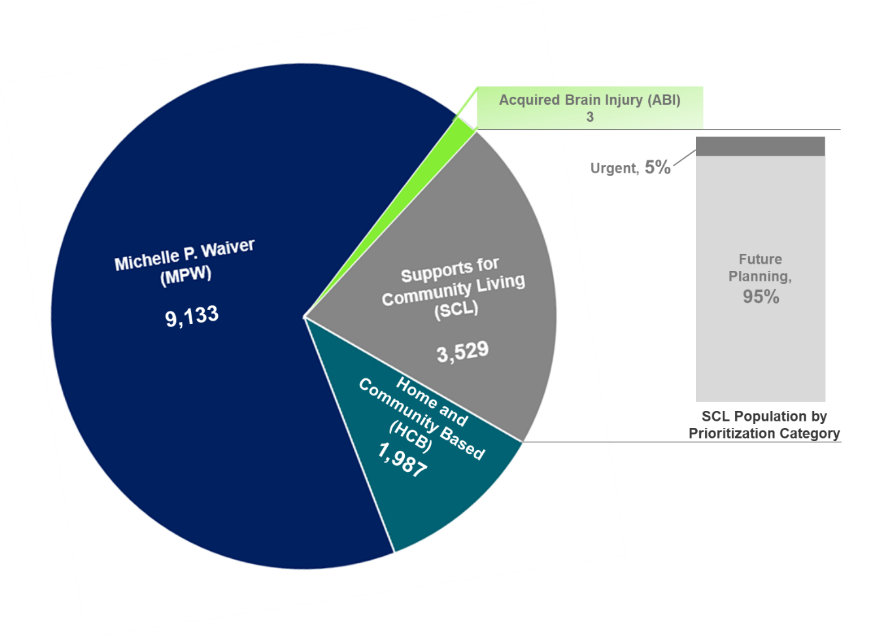

Additionally, as part of the application process, the party completing the application is asked to report the applicant’s primary diagnoses. **Table 10** below demonstrates the percentage of wait list participants who reported primary diagnoses that meet waiver targeting criteria based on their waiver application, as defined in **Section A**. Of note, waiver applications only began requiring recording of the primary diagnoses beginning September 2022. Only 32% of the current individuals placed on the MPW wait list and 27% on the SCL wait list were subject to the requirement. All individuals on the ABI-LTC and HCB wait lists were placed after September 2022. Further, the Cabinet cannot confirm whether an individual fully meets level of care and eligibility criteria until conducting the functional assessment.

**Table 10: Adherence to Wait List Eligibility Criteria as Reported by Applicants in their Waiver Intake Application[34]**

| **Waiver** | **Meets Targeting Criteria[35]** | **Data Not Available** |
| --- | --- | --- |
| **Acquired Brain Injury (ABI)** | N/A | N/A |
| **Acquired Brain Injury – Long Term Care (ABI-LTC)** | 100% (3) | 0% (0) |
| **Home and Community Based (HCB)** | 93.8% (1,864) | 5.6% (112) |
| **Michelle P. Waiver (MPW)** | 28.3% (2,583) | 71.5% (6,532) |
| **Model II (MIIW)** | N/A | N/A |
| **Supports for Community Living (SCL)** | 19.4% (686) | 80.6% (2,843) |

Once a waiver slot becomes available, the waiver slot uptake rate (i.e., estimated number of individuals from the wait list who ultimately qualify for a slot) varies amongst the various waiver wait lists. Implementation of updated wait list management processes in comparative states has shown that using more structured wait list management methods (e.g., the process used for the SCL waiver) results in a higher uptake rate. This suggests that a broadened approach to wait list management with more robust pre-screening will help increase the likelihood that a person on a wait list qualifies for a slot. Waivers that are currently managed on a chronological basis are likely to have a lower uptake rate. **Table 11** provides a breakdown of estimated waiver slot uptake rate by waiver program based on the current pre-screening processes.

**Table 11: Percentage of Waiver Wait List Individuals Who May Qualify for Waiver Slot Once Available [36]**

|  |  |
| --- | --- |
| **Estimated Percentages Based Upon Comparative State Research** | |
| Individuals who ultimately qualify for a waiver slot without verifying qualification prior to wait list placement | **50%** |
| Individuals who ultimately qualify for a waiver slot when information is provided regarding qualification prior to wait list placement | **90%** |

**F. Acuity Level of Individuals on the Wait List​**

In current state, the Cabinet’s wait list management processes only collect acuity information for individuals on the SCL waiver wait list. Through the waiver application for all waiver programs, the Cabinet collects information for each applicant such as services currently received, services needed, current living situation, abuse / neglect, and other factors. Although this information is helpful to initially understand an individual’s potential needs, it is not a direct proxy to acuity. It is also important to note that a person’s acuity of need is dynamic and can change over time. Anticipated changes to current review processes described at the end of this report will assist in a greater capacity to assess and address urgency of need for individuals on the wait list moving forward.

For purposes of meeting the HB 6 report, the Cabinet leveraged cabinet-level data from other sources that offer more current and complete indicators of the acuity of individuals on wait lists. The steps set forth below were designed to offer a proxy of acuity, acknowledging current-state 1915(c) wait list management practices do not consistently collect indicators of need for HCBS and the intensity of those indicators.

As the HB 6 report request is general in its request for *“****(f) The acuity level of individuals on the wait list,***” this approach offers a substantive response based on available data for legislative reporting purposes. The process below will also help address ***“(g) The level of care and services needed by individuals on the wait list.”***

**Step #1 Crosswalk Medicaid Identification Numbers to Enrollment Data**

|  |  |  |
| --- | --- | --- |
| **Step** | **Description** | **Anticipated Informational Value Related to Acuity** |
| **Step #1.** | Crosswalk Medicaid Identifications with those individuals on the wait list. | * Individuals on the wait list with Medicaid Identifications were further analyzed in steps below to attempt to understand additional indicators of acuity using MCO risk stratification data and Medicaid claims. |

The Cabinet determined that a high percentage of potential waiver enrollees on the wait list had Medicaid Identifications (IDs). That finding is suggestive that many individuals who are on a wait list meet financial eligibility and currently or previously had access to non-waiver services offered in the Medicaid State Plan. **Table 12** below breaks down the volume of wait lists with or without a Medicaid ID.

|  |  |
| --- | --- |
| **Table 12: Percentages of Individuals on the Waitlists with and without Medicaid ID as of June 30, 2024** | |
| Total with a Medicaid ID | **88%** |
| Total without a Medicaid ID | **11%** |

At this time, there is no further information available to proxy the acuity of individuals without a Medicaid ID. Individuals not actively enrolled in Medicaid may have various factors that influence their Medicaid enrollment status, including change in residence, death and/or a change in eligibility.

Individuals who were identified as having a Medicaid ID were further categorized as follows: those currently receiving waiver services through another waiver, those enrolled through a managed care organization (MCO), and those enrolled in a Medicaid fee-for-service (FFS) program (non-waiver) or have a Medicaid ID but not aligned with a MCO.[37] This breakdown was conducted to measure the volume of individuals on a wait list who actively engage in Medicaid services, assuming that individuals engaged in service have a demonstrable need of some kind. **Table 13** provides a breakdown of those on the wait list with a Medicaid ID.

|  |  |
| --- | --- |
| **Table 13:** **Total Wait List Volume as of June 30, 2024, with a Medicaid ID** | |
| **Factors: Breakdown of those with a Medicaid ID by 1915(c) waiver/MCO/FFS or No MCO enrollment** | |
| Total individuals who are served on a 1915(c) waiver while on a wait list | **34%** |
| Total individuals who are enrolled in Medicaid Managed Care | **60%** |
| Total individuals who have a Medicaid ID on file but either are not enrolled in Medicaid Managed Care or are slated to be served through Medicaid Managed Care but not aligned with a MCO**[38]** | **6%** |

Overall, it is noteworthy that a large percentage of wait listed individuals are actively accessing Medicaid services.

**Step #2 Cross-reference current wait list enrollees with a Medicaid ID with a Managed Care Organization (MCO)**

Individuals on a wait list who are not actively enrolled in a 1915(c) waiver or receiving long term care in an institutional setting are enrolled in the state’s Managed Care system and assigned to a health plan. The Cabinet partnered with managed care plans to gather information on managed care enrolled individual’s risk level, which is measured by plans using plan-specific risk stratification methodology. All managed care participants undergo risk stratification.

| **Step** | **Description** | **Anticipated Informational Value Related to Acuity** | |
| --- | --- | --- | --- |
| **Step #2.** | For wait list enrollees currently enrolled with a Medicaid ID, obtain a summary of risk levels for members on wait lists who are aligned with a MCO. | * As part of their contracts with Kentucky, MCOs are required to monitor the risk level and develop service tiers for their population. Therefore, some acuity level information about MCO-aligned enrollees is available. * Risk stratification directly aligns members of a managed care plan to an assigned care management level, which will offer further explanation of what resources individuals on the wait list have access to while awaiting a waiver slot. * This step also allows DMS to isolate individuals who are not managed care enrolled to identify the services they are receiving. |

Individuals on the wait list who were identified as having a Medicaid ID and who were aligned with a MCO were identified and separated by MCO. Each of the seven MCOs received a list of their assigned members who also were on a wait list. The MCO then populated the risk stratification and care management data for identified members, where applicable.

MCOs vary in their processes for risk stratification, risk categorization assignment, and how that assignment corresponds to an available care management level. Generally, each MCO uses the same characteristics to assign a risk stratification tier and case management category. Broadly, MCO members are assigned to one of three-to-four risk categories:

* **Low or Level 1**: Includes individuals who generally have lower acuity conditions. Corresponding MCO care management supports focus on disease prevention education, health promotion, and equipping members with tools for self-management.
* **Medium or Level 2:** Typically includes individuals with care management needs that warrant triage who need more support than Level 1. MCOs often include members in this category when they need further evaluation or have a chronic healthcare condition that presents an ongoing risk.
* **High/Complex or Level 3 or 4**: Includes individuals who have experienced a critical event or diagnosis, and members with multiple complex medical or behavioral conditions with poor clinical stability or at the end stage of treatment (i.e., hospice) or palliative care.

**Table 14** provides a percentage breakdown of the available data for individuals on the wait list who are enrolled with a MCO of the risk stratification category they have been assigned.

|  |  |
| --- | --- |
| **Table 14: Wait List Individuals Enrolled with a MCO Broken Down by Risk Stratification Category** | |
| High or Level of 3 or 4 | **14%** |
| Medium or Level 2 | **13%** |
| Low or Level 1 | **73%** |

The Cabinet observed that most individuals (73%) on a wait list and actively enrolled in managed care fall into lower risk levels. That finding may suggest a low intensity of need for HCBS.

All managed care enrolled individuals have the option to accept or decline MCO-provided care management services. The frequency and scope of care management activities vary depending on a person’s assigned risk level. 12% of individuals on a wait list engage in care management.

**Step #3 Analyze Episodes of Care for Individuals on a Wait List with a Medicaid ID**

As an additional measure of attempting to understand the acuity of individuals on the wait list, the Cabinet conducted utilization review of claims records to identify trends in episodes of care for individuals on the wait lists. Characteristically, individuals who are under-served and who have complex needs are at risk for higher rates of episodic care in various settings, including inpatient hospital and emergency department visits and crisis services.

| **Step** | | **Description** | **Anticipated Informational Value Related to Acuity** |
| --- | --- | --- | --- |
| **Step #3.** | Review Episodes of Care data for all individuals on the wait list with a Medicaid ID.[39] | * Analyzing episodes of care offer insights into what services individuals on the wait list are using as an indicator of over all need. The episodes of care analyzed included:   + Inpatient Hospitalization   + Emergency Department Visits   + High volume interaction per member, per month (“super-utilizers)   + Physical, Occupational and Speech Therapies   + Home Health Services   + Crisis Services   + EPSDT   + School Based Services * These episodes of care will help explain:   + Where use of services is an indicator of high acuity: super-utilizers, frequent hospitalizations, ED visits, crisis services, etc.   + Where use of services is suggestive of a true long-term care need: therapies, institutional episodes.   + Where lack of utilization of services that are accessible suggests a low degree of need and/or a targeted interest in a specific HCBS arrangement (e.g. participant directed services to reimburse care provided by currently unpaid caregiving supports). |

Below, the Cabinet offers a breakdown of inpatient and emergency department claims among individuals who are on the wait lists. Claims data spanned July 2022 – June 2023.

**Table 15: Inpatient and Emergency Department Use Among Individuals on a Wait List**

| **Cohort** | **Num. of Individuals** | **Count of Inpatient (IP) Claims** | | | | | **Count of Emergency Department (ED) Claims** | | | |
| --- | --- | --- | --- | --- | --- | --- | --- | --- | --- | --- |
| **0** | **1-2** | **3-4** | **5+** | **0** | | **1-2** | **3-4** | **5+** |
| **All Wait List Individuals** | 13,020 [40] | 92%  11,948 | 7%  925 | 0.8%  110 | 0.3%  37 | 77%  10,019 | | 18%  2,363 | 3%  387 | 2%  251 |
| **By Waiver-Specific Wait List** | | | | | | | | | | |
| **Acute Brain Injury Long Term Care**  **(ABI-LTC)[41]** | 3 | 100%  3 | 0%  0 | 0%  0 | 0%  0 | 67%  2 | | 0%  0 | 33%  1 | 0%  0 |
| **Home and Community Based (HCB)** | 1,478 | 84%  1,247 | 12%  189 | 2%  31 | 0.7%  11 | 77%  1,137 | | 17%  245 | 4%  56 | 3%  40 |
| **Michelle P. Waiver (MPW)** | 8,167 | 93%  7,554 | 7%  533 | 0.7%  61 | 0.2%  19 | 74%  6,034 | | 21%  1,694 | 3%  271 | 2%  168 |
| **Supports for Community Living (SCL)** | 3,372 | 93%  3,144 | 6%  203 | 0.5%  18 | 0.2%  7 | 84%  2,846 | | 13%  424 | 2%  59 | 1%  43 |

The setting in which individuals seek care can be correlated to acuity to some degree with those requiring care in an inpatient (IP) or emergency department (ED) care setting being of higher acuity than those whose care can be managed with outpatient services. An analysis of IP and ED utilization provides insight into the acuity level of those on the wait lists. Observations include:

* An overall low rate of episodes of inpatient hospitalization. 92% of individuals on a wait list experienced no inpatient admissions during the period analyzed. However, there are over 140 individuals who experienced multiple inpatient visits, suggestive of higher intensity of need.
* 77% of individuals on a wait list did not access the emergency department during the analytical period. However, there is a volume of over 600 individuals who had 3+ visits to an emergency department, which could reflect a higher intensity of need. Many of these emergency room visits were incurred by individuals on the MPW wait list.

Next, the Cabinet considered the rate of therapy (including physical / occupational / speech therapies) and home health claims for individuals on the wait list. The purpose of this analysis was to measure use of services which may indicate a potential need for long-term services and supports, including HCBS. Claims data analyzed spanned July 2022 – June 2023.

**Table 16: Therapy and Home Health Services Use Among Individuals on a Wait List**

| **Cohort** | **Num. of Individuals** | **Count of Therapy Claims** | | | | **Count of Home Health Claims** | | | |
| --- | --- | --- | --- | --- | --- | --- | --- | --- | --- |
| **0** | **1-2** | **3-4** | **5+** | **0** | **1-2** | **3-4** | **5+** |
| **All Wait List Individuals** | 13,020 [42] | 91%  11,829 | 1%  142 | 0.6%  78 | 8%  971 | 90%  11,657 | 2%  261 | 2%  217 | 7%  885 |
| **By Waiver-Specific Wait List** | | | | | | | | | |
| **Acute Brain Injury Long Term Care (ABI-LTC)[43]** | 3 | 100%  3 | 0%  0 | 0%  0 | 0%  0 | 67%  2 | 33%  1 | 0%  0 | 0%  0 |
| **Home and Community Based (HCB)** | 1,478 | 95%  1,405 | 0.8%  12 | 0.6%  9 | 4%  52 | 96%  1,411 | 2%  23 | 0.7%  10 | 2%  34 |
| **Michelle P. Waiver (MPW)** | 8,167 | 88%  7,220 | 1%  106 | 0.7%  56 | 10%  785 | 89%  7,286 | 2%  165 | 2%  142 | 7%  574 |
| **Supports for Community Living (SCL)** | 3,372 | 95%  3,201 | 0.7%  24 | 0.4%  13 | 4%  134 | 88%  2,958 | 2%  72 | 2%  65 | 8%  277 |

Overall, the Cabinet observed a low utilization rate of therapies and/or state plan home health for individuals enrolled in Medicaid who are on a waiver wait list. Eight percent of individuals on a wait list routinely accessed therapies more than 5 times last year. The majority of those users are from the MPW wait list, under the age of 18, and likely utilize therapy services to achieve developmental milestones.

Seven percent of individuals on a wait list routinely accessed state plan home health, following a similar trend of a higher volume of individuals on the MPW wait list compared to other waivers. Low utilization rates suggest that while there are pockets of potential for higher intensity of need for HCBS, overall use patterns suggest wait listed individuals may not be seeking alternate supports that are aligned to long-term care needs.

Additionally, the Cabinet explored the rate of crisis service utilization among individuals on the wait list, as a potential indicator of intensity of need. Our findings were that only 1 person accessed crisis services of the entire wait list population.

There is a significant population of pediatric individuals on a wait list (49% of individuals on the wait list are 18 or younger). The Cabinet examined use of alternate Medicaid services for children, including school-based services (SBS), Early Periodic Screening, Diagnosis and Treatment (EPSDT) services.

SBS include services provided to students to maximize reduction of physical and / or intellectual disabilities. SBS assist students to function at their best possible level, prevent loss of current functional abilities, or to correct any current defects or conditions. The purpose of analyzing SBS utilization was to understand the use of SBS services can be an indicator of a potential need for long-term services and supports. Claims data analyzed spanned July 2022 – June 2023.

**Table 17: School-Based Service Use Among Individuals on a Wait List**

| **Waiver** | **Num. of Individuals** | **Count of School Based Services (SBS) Claims** | | | | | |
| --- | --- | --- | --- | --- | --- | --- | --- |
| **0** | **1-100** | **101-200** | **201-300** | **301-400** | **401-500** |
| **All Wait List Individuals** | 6,295 | 63%  3,955 | 36%  2,296 | .05%  31 | .02%  4 | .03%  9 | 0 |
| **By Waiver-Specific Wait List** | | | | | | | |
| **Acute Brain Injury Long Term Care (ABI-LTC)[44]** | 0 | 0 | 0 | 0 | 0 | 0 | 0 |
| **Home and Community Based (HCB)** | 240 | 76%  183 | 23%  55 | 1%  2 | 0 | 0 | 0 |
| **Michelle P. Waiver (MPW)** | 4,929 | 59%  2,931 | 40%  1,966 | .05%  21 | .02%  3 | .03%  8 | 0 |
| **Supports for Community Living (SCL)** | 549 | 49%  271 | 50%  275 | .33%  1 | .33%  1 | .33%  1 | 0 |

Overall, the Cabinet observed a slightly higher utilization rate of SBS for Medicaid-enrolled individuals on a waiver wait list. 36% of eligible children who are on a wait list accessed SBS therapies 1-100 times last year. Most of those users are from the SCL and MPW wait lists who likely utilize SBS to support achievement of developmental milestones.

Finally, the Cabinet considered the count of EPSDT claims for individuals on the wait list who were 18 years of age and younger.[45] The purpose of this analysis was to attempt to explore services that are an indicator of a potential need for long-term services and supports via HCBS. Claims data spanned July 2022 – June 2023.

**Table 18: EPSDT Service Use Among Individuals on a Wait List**

| **Waiver** | **Num. of Individuals** | **Count of EPSDT Claims** | | | | | |
| --- | --- | --- | --- | --- | --- | --- | --- |
| **0** | **1-100** | **101-200** | **201-300** | **301-400** | **401-500** |
| **All Wait List Individuals** | 6,297 | 83%  5,236 | 15%  942 | 1%  64 | .06%  42 | .04%  12 | 1 |
| **By Waiver-Specific Wait List** | | | | | | | |
| **Acute Brain Injury Long Term Care (ABI-LTC)** | 0 | 0 | 0 | 0 | 0 | 0 | 0 |
| **Home and Community Based (HCB)** | 4%  270 | 85%  230 | 14%  37 | .06%  2 | .04%  1 | 0 | 0 |
| **Michelle P. Waiver (MPW)** | 90%  5,434 | 83%  4,513 | 15%  812 | .05%  56 | .03%  40 | .02%  12 | 1 |
| **Home and Community Based (HCB)** | 5%  270 | 85%  230 | 14%  37 | .06%  2 | .04%  1 | 0 | 0 |
| **Supports for Community Living (SCL)** | 9%  593 | 83%  493 | 16%  93 | .09%  6 | .01%  1 | 0 | 0 |

DMS routinely notifies enrollees (i.e., at least twice a year) of the availability of EPSDT services, to proactively link children to services that offer early intervention and targeted intervention. Overall, we observed low utilization of EPSDT services for individuals enrolled in Medicaid who are also on a waiver wait list. Roughly 15% of children on a wait list routinely utilized EPSDT services.

Exploring the use of other health care services offers some insights on the population of individuals on the wait lists, given the limitations of the current data available and recognizing that needs change over time. While overall episodes of care were often low, there are pockets of high utilization that are suggestive of a higher intensity of need for timely access to waiver services. This finding reinforces the need to implement options to consider urgency of need across additional waivers to prioritize slot allocations to individuals with a higher acuity, while redirecting individuals who express interest in HCBS but may not meet level of care to alternative Medicaid and non-Medicaid services and supports.

**G. Level of Care and Services Needed by Individuals on the Wait List**

As part of the current HCBS waiver and wait list placement process, applicants for waiver services are asked to select “requested services needed” from a list of potential waiver services. While specific service needs are not evaluated until after an individual is allocated a slot on a waiver and a formal assessment conducted, the services initially chosen offer insight into which services individuals are generally interested in receiving and the type of supports needed. While the selected services may not fully align with the needs identified by assessors through the functional assessment, the process provides valuable insights to help wrap around a general understanding of prospective intensity of need for waiver services.

The services in **Table 19** reflect what services individuals on the wait list have requested and selected as “needed” upon their placement to the wait list. Implementing future state recommendations described in*Section 2. Recommendations to Improve HCBS Waiver Wait List Management*will improve information collection on service interest and more readily link individuals who are interested in HCBS to alternate programs and services.

**Table 19: Services Needed per Individual Self-Declaration by Waiver Wait List[46]**

| **Services Needed by Waiver Applicants** | **ABI-LTC[47]** | **HCB** | **MPW** | **SCL** |
| --- | --- | --- | --- | --- |
| **3** | **1,987** | **9,133** | **3,529** |
| Attendant Care Services | 1 | 1,461 | 813 | 147 |
| Behavior Support | 2 | 148 | 1,505 | 412 |
| Case Management | 3 | 1,841 | 2,430 | 647 |
| Community Access/Community Living Support | 1 | 158 | 1,411 | 491 |
| Day Training/Adult Day Health Care | 2 | 456 | 655 | 310 |
| Homemaking | 1 | 996 | 454 | 135 |
| Mental Health Counseling/Meds/Psych Services | 2 | 104 | 846 | 298 |
| No Service Needs Captured | 0 | 64 | 6,573 | 2,859 |
| Nursing | 0 | 76 | 129 | 37 |
| Occupational Therapy | 2 | 285 | 1,559 | 301 |
| Personal Assist. /Companion Services/Personal Care | 1 | 1,057 | 1,450 | 397 |
| Physical Therapy | 1 | 270 | 870 | 179 |
| Residential | 2 | 32 | 376 | 262 |
| Respite | 0 | 548 | 1,622 | 448 |
| Speech Therapy | 2 | 202 | 1,541 | 299 |
| Supported Employment | 0 | 34 | 500 | 213 |
| **Grand Total** | **20** | **7,732** | **22,734** | **7,435** |

There is diversity in the services that individuals indicate interest in receiving. The service with the highest response rate is case management. Additionally, many individuals on a wait list are interested in community- and home-based supports specifically available through the waivers, including attendant care, community access support and respite services. Others are interested in specialized services including behavioral supports and therapies, which could potentially be offered via state plan services while individuals are awaiting a waiver slot.

**H. Average Cost of Waiver Services Provided​**

The average per capita spend for each waiver program differs significantly. Differences in expenditure are due to inherent contrasts in level of care and in the range of services across each waiver program. For example, the MIIW waiver, which exclusively provides skilled nursing services to ventilator-dependent individuals, is anticipated to have higher costs than the HCB waiver, which provides assistance to elderly adults and individuals with physical disabilities through services such as respite and attendant care, case management, and environmental and home adaptations.

**Table 20** below demonstrates the average cost of services for each of the six HCBS waivers in Kentucky.

**Table 20: Average per Capita Expenditures for Waiver Services[48]**

| **Waiver** | **Average Cost to Provide Waiver Services** |
| --- | --- |
| **Acquired Brain Injury (ABI)[49]** | $108,018 |
| **Acquired Brain Injury Long Term Care (ABI-LTC)[50]** | $79,692 |
| **Home and Community Based Waiver (HCB)[51]** | $22,565 |
| **Michelle P. Waiver (MPW)[52]** | $34,699 |
| **Model II Waiver (MIIW)[53]** | $76,531 |
| **Supports for Community Living (SCL)[54]** | $91,991 |

**I. Date of Entry and Length of Time on the Wait List​**

The average length of time an individual spends on a wait list differs between waiver programs. **Table 21** shows the variation in average time individuals spend on the waiver-specific wait lists.

**Table 21: Average Time Individuals Stay on the Wait List[55]**

| **Waiver** | **Wait List Count** | **Average Days on the Wait List** | **Average Weeks on the Wait List** |
| --- | --- | --- | --- |
| **ABI-LTC[56]** | 3 | 20 | 3 |
| **HCB** | 1,987 | 56 | 9 |
| **MPW** | 9,133 | 1,283 | 184 |
| **SCL** | 3,529 | 1,592 | 228 |
| **Overall** | **14,652 [57]** | **1,191** | **171** |

At the start of each fiscal year, waiver program enrollment caps are adjusted based on identified waiver-specific need. Beginning in SFY 2021, new waiver slots have become available each year. Effective July 1, 2024, four of the state’s six waiver programs increased their capacity. 25 slots were added to the ABI waiver, 125 slots were added to the SCL waiver, and both HCB and MPW increased by 250 slots. These newly allocated program spaces will allow many individuals on a wait list to access waiver services. The benefit of new slots is limited by the increase in waiver demand in recent years.

Additional factors to consider when reviewing the average length of time an individual may spend on the wait list include:

* Current KARs do not include procedures to account for individuals receiving services through a different waiver or if their service needs are met though non-waiver resources.
* Many waiver applicants will request to be added to waiver wait lists years before they anticipate needing the services due to anticipated long wait times and to ensure that needed documentation to confirm eligibility is preserved within MWMA for the future.

**J. Number of Applicants on the Wait List for More Than One Waiver Program**

Current waiver regulations do not limit waiver participants from being placed on more than one waiver wait list simultaneously. The duplication of applicants across wait lists inflates the perceived number of individuals awaiting a waiver slot.

A total of 1,758 individuals are currently active on more than one wait list. The MPW wait list has the highest incidence of individuals on an additional wait list, with 1,754 individuals also awaiting a slot for another waiver. The SCL waiver wait list has 1,522 individuals waiting on at least one other program and HCB has 287. The most common overlap occurs between individuals on the wait list for MPW and SCL, with 1,518 individuals on both lists, demonstrating an opportunity to streamline wait list processes for these two waivers that serve the same target population. **Figure 2** below demonstrates the overlap in individuals on the wait lists across waivers.

**Figure 2. Number of Waiver Applicants on More than One Wait List[58]**

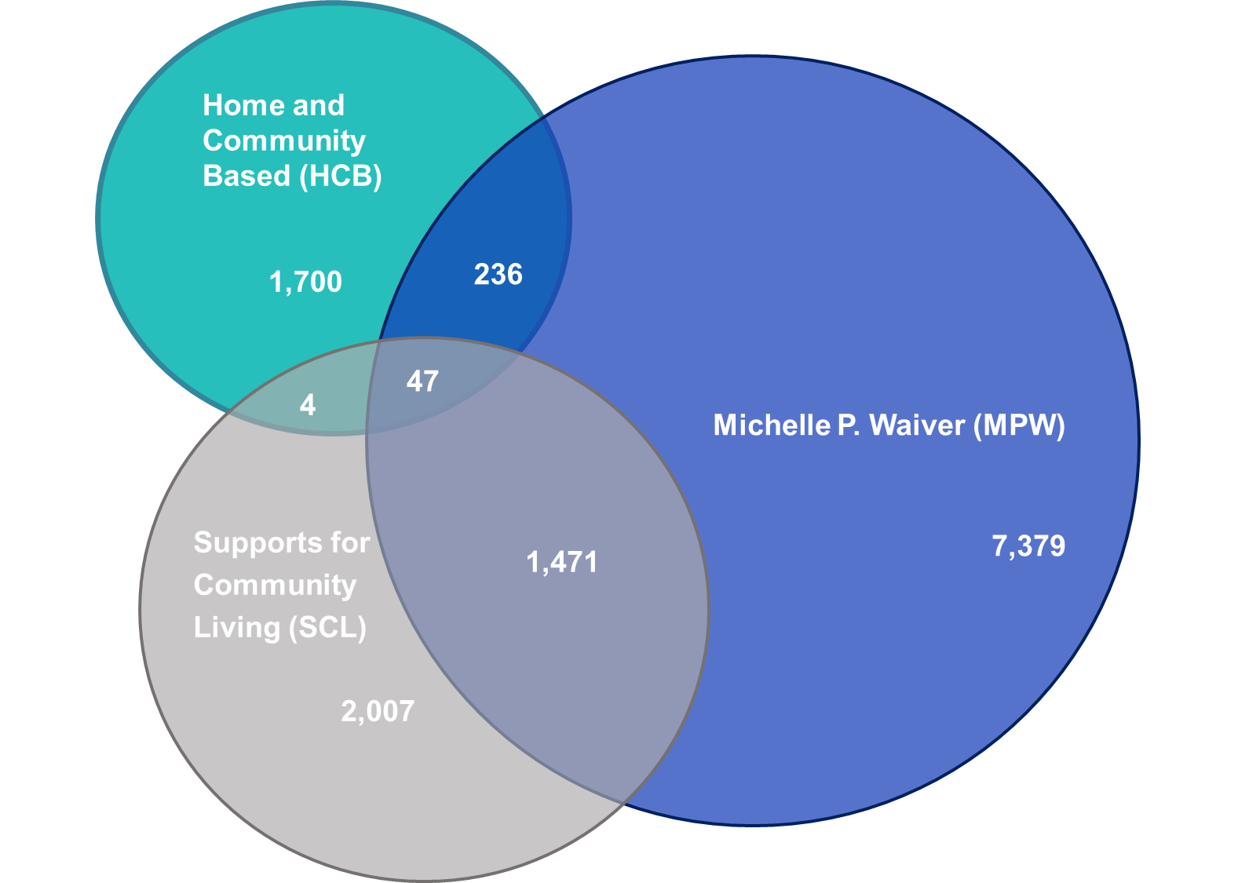

**Section 2. Recommendations to Improve HCBS Waiver Wait List Management**

Based on the above findings and the results of a scan of national best practices and wait list management initiatives among other states completed in early 2024, the Cabinet identified three primary administrative and process-focused recommendations to improve the overall HCBS waiver wait list management process:

1. **Align Wait List Administrative Regulations and Policies Across Waivers:** The Cabinet can amend each waiver and update relevant KARs to streamline wait list management processes and requirements across all HCBS waiver programs.
2. **Standardize Waiver Application and Wait List Placement Processes:** The Cabinet can develop updated streamlined process to confirm waiver eligibility prior to placing individuals on the wait lists and prioritize slot allocation to individuals with the highest level of need for HCBS.
3. **Modernize Wait List Management Data Collection Systems:** The Cabinet can integrate data collection and analysis using existing systems to develop a publicly available wait list data dashboard. The dashboard will help the Cabinet deliver data-driven updates to CMS, the Kentucky General Assembly, individuals on the wait list, and other public stakeholders (e.g., advocacy groups). A dashboard will also help the State meet Federal Requirements per the *Ensuring Access to Medicaid Services Final Rule.*59

Implementing each of these recommendations will help the Cabinet build towards the increased wait list and wait list management reporting requirements included in CMS’ *Ensuring Access to Medicaid Services* Final Rule*.*[59] Wait list-related requirements outlined in the Final Rule must be fully implemented by 2027.

The Cabinet is reviewing the resources that may be required to implement each of these recommendations.

**Conclusion**

In response to HB 6, the Cabinet conducted a focused assessment of the current HCBS waiver wait list populations, management policies and processes, and other factors that impact the overall operations of the waiver wait lists. Based on findings from this assessment, as well as prior program assessments, the Cabinet developed three recommendations as listed in **Table 22**. The Cabinet believes implementing the listed recommendations will assist with improving efficiency and management of the wait lists and assist Kentucky to prepare for the CMS’s *Ensuring Access to Medicaid Services* Final Rule.

**Table 22: Wait List Management Recommendations and Timeline**

|  |  |
| --- | --- |
| **Recommendation** | **Implementation Timeline[60]** |
| 1. **Align Wait List Administrative Regulations and Policies Across Waivers** | Oct. 2024 – Mar. 2027  (29 months) |
| 1. **Standardize Waiver Application and Wait List Placement Processes** | Oct. 2024 – Aug. 2026  (23 months) |
| 1. **Modernize Wait List Management Data Collection Systems** | Oct. 2024 – Aug. 2026  (23 months) |

The Cabinet is eager to modernize our approach to wait list management. We recognize the opportunity to refine our methods to better pre-screen individuals expressing interest in waivers where slots are not available to better prioritize resource allocations to people most at-risk and in need of HCBS. DMS and its operating agency partners, DBHDID and DAIL look forward to continued partnership with the General Assembly, advocacy networks who support the various populations served by waivers and especially individuals on the wait list and their representatives as we move forward.

**Appendix A. Acronyms**

|  |  |
| --- | --- |
| **ABI** | Acquired Brain Injury Waiver |
| **ABI-LTC** | Acquired Brain Injury – Long Term Care Waiver |
| **ADRC** | Aging and Disability Resource Centers |
| **CHFS** | Cabinet for Health and Family Services |
| **CMHC** | Community Mental Health Center |
| **CMS** | Centers for Medicare and Medicaid Services |
| **DAIL** | Department for Aging and Independent Living |
| **DBHDID** | Department for Behavioral Health, Developmental, and Intellectual Disabilities |
| **DCBS** | Department for Community Based Services |
| **DMS** | Department for Medicaid Services |
| **ED** | Emergency Department |
| **EPSDT** | Early and Periodic Screening, Diagnostic, and Treatment |
| **FFS** | Fee-for-Service |
| **HB 6** | House Bill 6 |
| **HCB** | Home and Community Based Waiver |
| **HCBS** | Home- and Community-Based Services |
| **HHS** | Department of Health and Human Services |
| **ICF/IID** | Intermediate Care Facilities for Individuals with Intellectual Disabilities |
| **IDD** | Intellectual and/or Developmental Disabilities |
| **IP** | Inpatient |
| **IQ** | Intelligence Quotient |
| **K-HAT** | Kentucky Home Assessment Tool |
| **KAR** | Kentucky Administrative Regulation |
| **MCO** | Managed Care Organization |
| **MIIW** | Model II Waiver |
| **MPW** | Michelle P. Waiver |
| **MWMA** | Medicaid Waiver Management Application |
| **OATS** | Office of Application Technology Services |
| **PCSP** | Person-Centered Service Plan |
| **POC** | Plan of Care |
| **SBS** | School-Based Services |
| **SCL** | Supports for Community Living Waiver |
| **SFY** | State Fiscal Year |
| **SIS** | Supports Intensity Scale |

**Appendix B. 1915(c) HCBS Waiver Enrollment Process Flow**

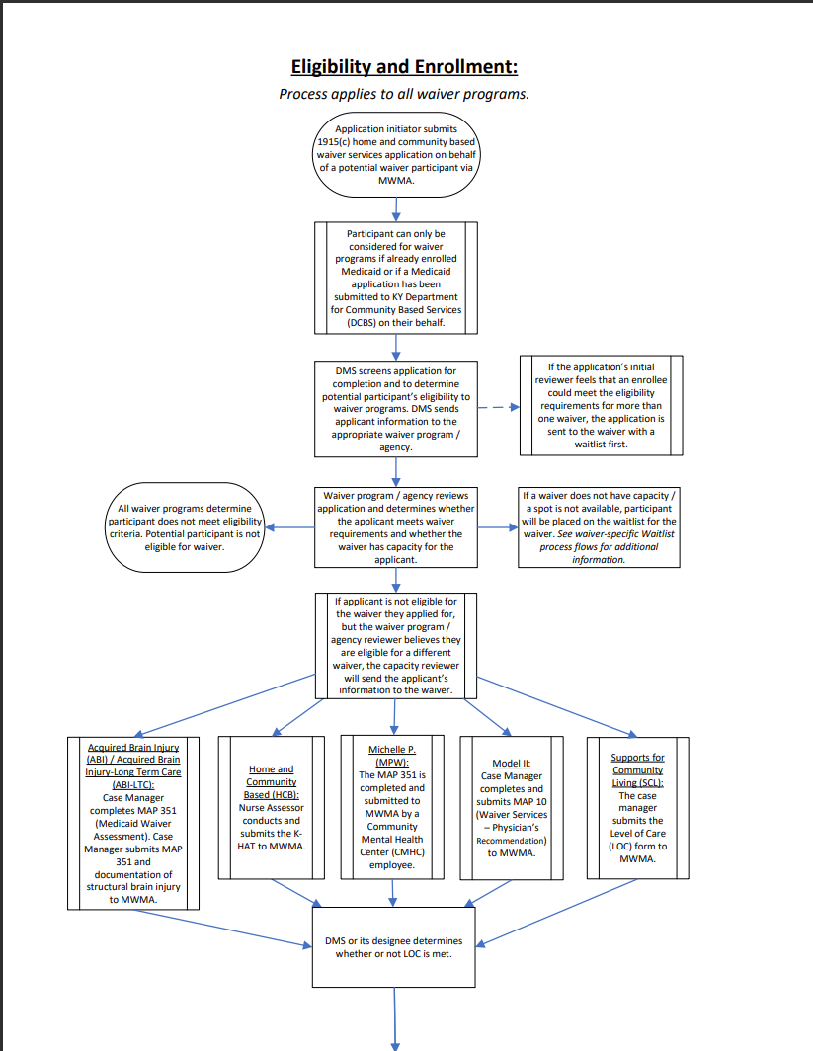

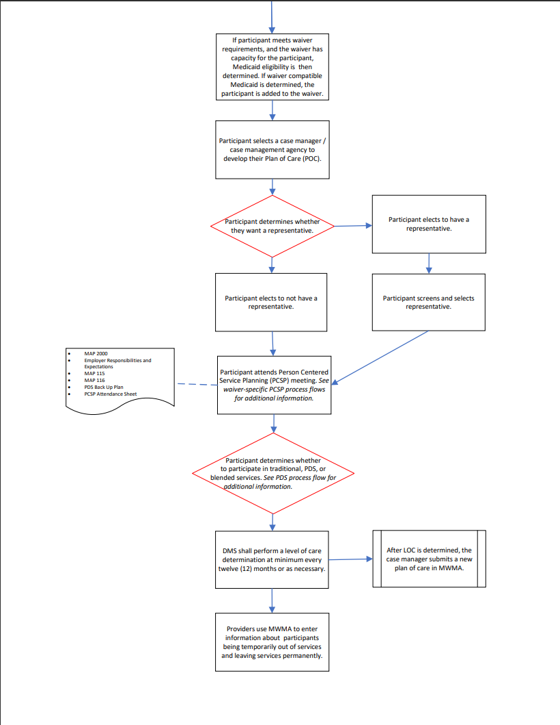

**Appendix C. 1915(c) HCBS Waiver Wait List Management Process Flow (ABI, ABI-LTC, and SCL Waivers)**

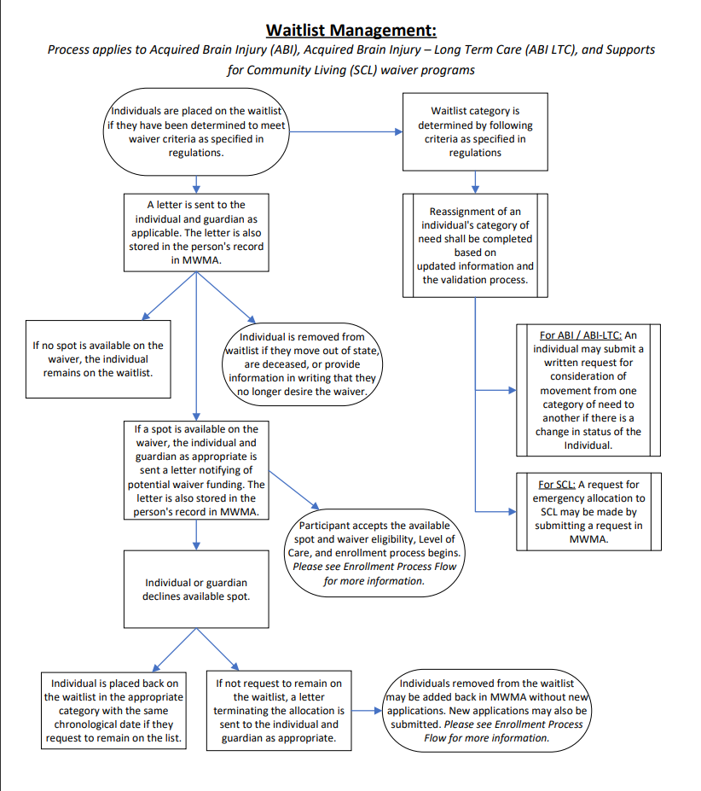

**Appendix D. 1915(c) HCBS Waiver Wait List Management Process Flow (HCB and MPW Waivers)**

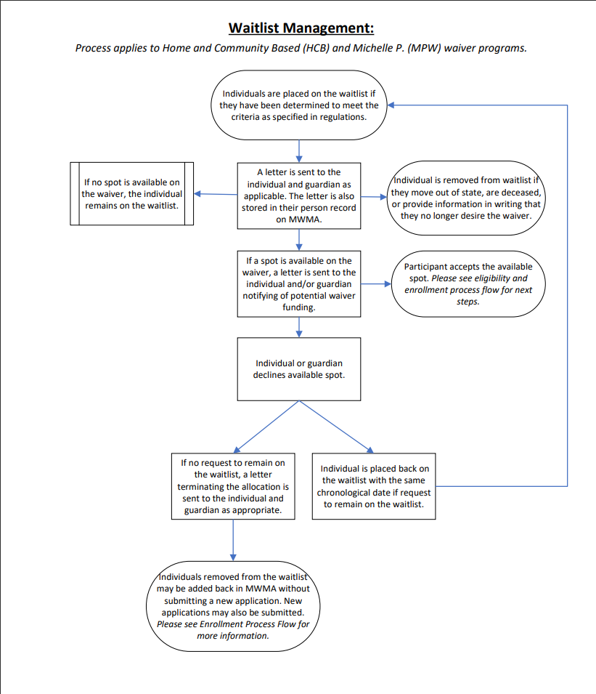

1. Risk-stratification categories identify the intensity of services and supports an individual needs to maintain their health. Categories range from low to high.
2. Claims data represents State Fiscal Year 2023 (i.e., July 1, 2022 – June 30, 2023).
3. Centers for Medicare & Medicaid Services (CMS), Department of Health and Human Services (HHS). “Medicaid Program; Ensuring Access to Medicaid Services.” Federal Register, 10 May 2024, <https://www.federalregister.gov/documents/2024/05/10/2024-08363/medicaid-program-ensuring-access-to-medicaid-services>
4. Kentucky General Assembly. “House Bill 6” (page 104). 12 April 2024. <https://apps.legislature.ky.gov/recorddocuments/bill/24RS/hb6/bill.pdf>
5. 907 KAR 1:022. Nursing facility services and intermediate care facility for individuals with an intellectual disability services. <https://apps.legislature.ky.gov/law/kar/titles/907/001/022/>
6. HCBS waiver programs provide an array of services designed to support individuals' long-term care needs and person-centered goals for community living, such as case management, homemakers, personal care, and adult day health services.
7. Social Security Act. Title 1915. <https://www.ssa.gov/OP_Home/ssact/title19/1915.htm> . During the waiver review process, the State proposes a data-driven enrollment cap based on available funding and historical service utilization. CMS reviews the proposal and data sources to determine whether the proposed cap is funded and reasonable based on historical trends.
8. As of July 1, 2024, additional slots have been allocated to the ABI-LTC, HCB, MPW, and SCL waivers. Please refer to Table 3 available on Page 8 for additional information.
9. Acquired Brain Injury Branch, Cabinet for Health and Family Services (CHFS). <https://www.chfs.ky.gov/agencies/dms/dca/Pages/abi.aspx>
10. As of October 1, 2024, ABI-LTC waiver does not have a wait list.
11. Home and Community Based Waiver, Cabinet for Health and Family Services (CHFS). <https://www.chfs.ky.gov/agencies/dms/dca/Pages/hcb-waiver.aspx>
12. Michelle P. Waiver, Cabinet for Health and Family Services (CHFS). <https://www.chfs.ky.gov/agencies/dms/dca/Pages/mpw.aspx>
13. Model II Waiver, Cabinet for Health and Family Services (CHFS). <https://www.chfs.ky.gov/agencies/dms/dca/Pages/mIIws.aspx>
14. Supports for Community Living Waiver, Cabinet for Health and Family Services (CHFS). <https://www.chfs.ky.gov/agencies/dms/dca/Pages/scl-waiver.aspx>
15. Centers for Medicare & Medicaid Services (CMS), Department of Health and Human Services (HHS). “Medicaid Program; Ensuring Access to Medicaid Services.” Federal Register, 10 May 2024, <https://www.federalregister.gov/documents/2024/05/10/2024-08363/medicaid-program-ensuring-access-to-medicaid-services>
16. Kentucky General Assembly. “House Bill 6” (pages 100-101). 12 April 2024. <https://apps.legislature.ky.gov/recorddocuments/bill/24RS/hb6/bill.pdf>
17. Wait list values are as of June 30, 2024.
18. Cabinet for Health and Family Services (CHFS). Department for Medicaid Services (DMS). “Medicaid Waiver Services Fact Sheet”. Jan. 2024. <https://www.chfs.ky.gov/agencies/dms/MAPForms/Map418.pdf>
19. Application initiators can include designated individuals at Community Mental Health Centers (CMHCs) or Aging and Disability Resource Centers (ADRC).
20. Confirming Medicaid / financial eligibility is not required for and individual to be placed on a waiver-specific wait list.
21. Cabinet for Health and Family Services (CHFS). Department for Medicaid Services (DMS). “Waiver Services Physician’s Recommendation (Map 10)”. Link: <https://www.chfs.ky.gov/agencies/dms/MAPForms/Map10.pdf>
22. Most KARs define waiver-specific qualifications for the assessor.
23. Prior to enrollment, the Cabinet determines whether applicants to SCL meet waiver eligibility criteria using the adaptive behavior assessment and psychological evaluation.
24. Written documentation by law enforcement or court personnel shall be required to support the validation of a history of arrest.
25. See 907 KAR 3:090 for additional information. Personal experience may refer to a review committee member’s experience serving individuals with a brain injury or cognitive disability, having a family member with a brain injury or a cognitive disability, etc.
26. Waiver capacity and the number of participants with prior authorized services are counts as of June 30, 2024. As of July 1, 2024, additional slots have been allocated to the ABI-LTC, HCB, MPW, and SCL waivers. Please refer to Table 3 available on Page 8 for additional information.
27. “Waiver Capacity in Use” includes individuals enrolled in waiver services and individuals with capacity reserved that are still going through the waiver assessment process (i.e., individuals awaiting level of care assessment and / or determination, and individuals pending Medicaid eligibility determination).
28. Wait list data is as of June 30, 2024. Individuals can be listed on more than one wait list simultaneously. The total value includes duplicates.
29. Wait list data as of June 30, 2024.
30. As of October 1, 2024, ABI-LTC waiver does not have a wait list.
31. Individuals can be listed on more than one wait list simultaneously. The total value includes duplicates.
32. Individuals can be listed on more than one wait list simultaneously. The total value includes duplicates.
33. As of October 1, 2024, ABI-LTC waiver does not have a wait list.
34. Wait list data as of June 30, 2024.
35. As reported by the waiver applicant in their *Kentucky Medicaid Waiver Application.*
36. Reasons an individual ultimately may not qualify for a waiver can vary, including, but not limited to, not meeting financial criteria, refusing a waiver slot, moved out of state, not meeting level of care requirements, etc.
37. Individuals enrolled in a 1915(c) program and individuals receiving long term care in institutions are carved out of Medicaid Managed Care.
38. These individuals are either in an institution or at the time of the data query, no assigned MCO designation was on file.
39. It is noted that claims sometimes “lag” i.e., are not billed in real-time. Providers generally have up to a year to bill from the date of service. However, there is no reason to believe that utilization of available claims does is not indicative of overall usage.
40. Wait list data is as of June 30, 2024. While these individuals had a Medicaid ID, these individuals can be listed on more than one wait list simultaneously. The total value includes duplicates.
41. As of October 1, 2024, ABI-LTC waiver does not have a wait list.
42. Wait list data is as of June 30, 2024. While these individuals had a Medicaid ID, these individuals can be listed on more than one wait list simultaneously. The total value includes duplicates.
43. As of October 1, 2024, ABI-LTC waiver does not have a wait list.
44. As of October 1, 2024, ABI-LTC waiver does not have a wait list.
45. For an overview of EPSDT services, see <https://www.chfs.ky.gov/agencies/dms/provider/Pages/epsdtscreening.aspx>
46. Wait list data is as of June 30, 2024. While these individuals had a Medicaid ID, these individuals can be listed on more than one wait list simultaneously.
47. As of October 1, 2024, ABI-LTC waiver does not have a wait list.
48. The average per capita Medicaid spend was collected from the CMS 372s. Each 372 report has a unique fiscal year (i.e., start and end month) and the most recent report data available is from 2022. 372 report data has an 18-month delay.
49. Acquired Brain Injury Acute waiver. CMS 372. Jan. 01, 2022 – Dec. 31, 2022 (Run date: Apr. 4, 2024).
50. LTC Brain Injury Waiver. CMS 372. Jul. 01, 2021 – Jun. 30, 2022 (Run date: Oct. 4, 2023).
51. HCB Waiver. CMS 372. Aug. 01, 2021 – Jul. 31, 2022 (Run date: Oct. 5, 2023).
52. LTC Michelle P. Waiver. CMS 372. Sep. 01, 2021 – Aug. 31, 2022 (Run date: Dec. 6, 2023).
53. Model II Waiver. CMS 372. Oct. 01, 2021 – Sep. 30, 2022 (Run date: Jan. 4, 2024).
54. SCL Waiver. CMS 372. Mar. 01, 2022 – Feb. 28, 2023 (Run date: Jun. 5, 2024).
55. Wait list data is as of June 30, 2024.
56. As of October 1, 2024, ABI-LTC waiver does not have a wait list.
57. Individuals can be listed on more than one wait list simultaneously. The total value includes duplicates.
58. Wait List data is as of June 30, 2024.
59. Centers for Medicare & Medicaid Services (CMS), Department of Health and Human Services (HHS). “Medicaid Program; Ensuring Access to Medicaid Services.” Federal Register, 10 May 2024, <https://www.federalregister.gov/documents/2024/05/10/2024-08363/medicaid-program-ensuring-access-to-medicaid-services>
60. Implementation timelines are preliminary and based upon information currently known by the Cabinet. Timelines are subject to change based upon newly identified implementation factors.